 | 

Alternative Assessment Tool (AAT) Report on
“Design and Verification of Combinational and Sequential Digital Modules using Verilog HDL”
Submitted in partial fulfilment of the requirements of the Alternative Assessment Tool (AAT) for the course
ADVANCED DIGITAL AND LOGIC DESIGN (ADLD)
[Course Code: 23ECSPE1AD]
Submitted by
Pranith T Prajosh 1BF24EC110
Submitted to
Prof. Ajaykumar Devarapalli
DEPARTMENT OF ELECTRONICS AND COMMUNICATION ENGINEERING
BMS College of Engineering
Bull Temple Road, Basavanagudi, Bengaluru-560019
Academic Year
2026 – 2027
INDEX
S.NO | CONTENTS | PAGE NO
1 | Comparator (Combinational) | 3-4
2 | Shift Register (Sequential) - SISO | 4-6
3 | Conclusion | 7
4 | Acknowledgement | 8
Comparator (Combinational)
WORKING PRINCIPLE
The cmp_4bit module is a purely combinational circuit with two 4-bit inputs, A and B, and three outputs. It uses continuous assign statements to evaluate the relational operators >, < and == on the inputs, so every output responds immediately to any change in A or B and no clock is needed. A_gt_B goes HIGH when A is greater than B, A_lt_B goes HIGH when A is less than B, and A_et_B goes HIGH when both inputs are equal. For any pair of inputs exactly one of these three conditions is true, so only one output is HIGH at a time.
CODE:
module cmp_4bit (
input wire [3:0] A,
input wire [3:0] B,
output wire A_gt_B,
output wire A_lt_B,
output wire A_et_B
);

assign A_gt_B = (A > B);
assign A_lt_B = (A < B);
assign A_et_B = (A == B);

endmodule
TESTBENCH:
`timescale 1ns/1ps

module tb_4bit_cmp;

reg [3:0] A;
reg [3:0] B;

wire A_gt_B;
wire A_lt_B;
wire A_et_B;

cmp_4bit uut (
.A(A),
.B(B),
.A_gt_B(A_gt_B),
.A_lt_B(A_lt_B),
.A_et_B(A_et_B)
);

initial begin
A = 4'd7; B = 4'd7; #10;
A = 4'd9; B = 4'd4; #10;
A = 4'd3; B = 4'd11; #10;
A = 4'd0; B = 4'd0; #10;
A = 4'd14; B = 4'd8; #10;
A = 4'd6; B = 4'd13; #10;

$finish;
end

endmodule
OUTPUT WAVEFORM:
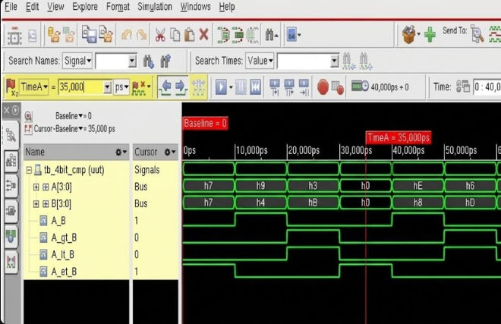

Shift Register (Sequential) - SISO
WORKING PRINCIPLE
The siso_4bit module stores data in a 4-bit register, shift_reg, which is updated on every rising edge of clk. On each edge the stored bits move one position towards the MSB and the new bit at serial_in enters the LSB, as written by {shift_reg[2:0], serial_in}. The output serial_out is taken from shift_reg[3], so a bit applied at serial_in reaches the output only after four clock edges. Since reset appears in the sensitivity list (posedge clk or posedge reset), a HIGH on reset clears the register to 0000 immediately, without waiting for a clock edge.
CODE:
`timescale 1ns/1ps

module siso_4bit (
input wire clk,
input wire reset,
input wire serial_in,
output wire serial_out
);

reg [3:0] shift_reg;

always @(posedge clk or posedge reset) begin
if (reset)
shift_reg <= 4'b0000;
else
shift_reg <= {shift_reg[2:0], serial_in};
end

assign serial_out = shift_reg[3];

endmodule
TESTBENCH:
`timescale 1ns/1ps

module tb_siso_4bit;

reg clk;
reg reset;
reg serial_in;
wire serial_out;

siso_4bit uut (
.clk(clk),
.reset(reset),
.serial_in(serial_in),
.serial_out(serial_out)
);
always #5 clk = ~clk;
initial begin
clk = 0;
reset = 1;
serial_in = 0;
#12 reset = 0;

// Serial data sequence: 1 0 1 1 0 0 1 0
serial_in = 1; #10;
serial_in = 0; #10;
serial_in = 1; #10;
serial_in = 1; #10;
serial_in = 0; #10;
serial_in = 0; #10;
serial_in = 1; #10;
serial_in = 0; #10;

#40 $finish;
end
endmodule
OUTPUT WAVEFORM:
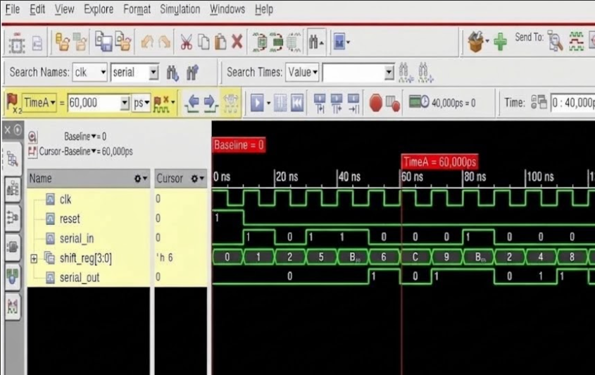
CONCLUSION
Thus, the 4-bit Comparator and the 4-bit Serial-In Serial-Out (SISO) Shift Register were successfully designed and simulated using Verilog HDL in Cadence. The comparator, modelled purely with continuous assign statements, compares two 4-bit binary inputs and indicates whether A is greater than, less than or equal to B. The simulated waveform confirmed that its outputs respond immediately to any change in the inputs and that exactly one of A_gt_B, A_lt_B and A_et_B is HIGH at any instant, including the equal cases such as A = B = 7 and A = B = 0. The SISO shift register, modelled with a clocked always block and an asynchronous reset, shifts the serial input through its four stages on every rising clock edge and delivers it at the serial output after four clock cycles. The waveform verified that reset clears the register to 0000 and that the stored value of shift_reg follows the applied serial data sequence. Together, the two experiments demonstrated the difference between combinational logic, whose outputs depend only on the present inputs, and sequential logic, whose outputs depend on the clock and the stored state. They also gave practical experience in writing synthesizable Verilog modules, developing self-checking-style testbenches with a variety of input combinations, and analysing timing waveforms in the simulator. The functionality of both circuits was verified successfully through simulation.
GitHub Repository: https://github.com/Pranith-2006/ADLD_AAT_PARTB-1BF24EC110
ACKNOWLEDGEMENT
I would like to express my sincere gratitude to Prof. Ajaykumar Devarapalli for his valuable guidance and support throughout the completion of this Alternative Assessment Tool (AAT) report for the course Advanced Digital and Logic Design (ADLD).
I am also thankful to the Department of Electronics and Communication Engineering, BMS College of Engineering, for providing me with the opportunity and academic environment to carry out this work on the design and verification of combinational and sequential digital modules using Verilog HDL.
Finally, I would like to thank everyone who contributed directly or indirectly to the successful completion of this report.
Pranith T Prajosh
USN: 1BF24EC110

